1 Software Installation
The management software can manage the powerline devices in the same electricity meters.
❶ Firstly, login to Tenda website: www.tendacn.com>> software downloading, then run the management software to install procedure, finally double click the icon of the management software 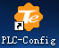 after installation and open it.

2 Device Management
Run the management software after installation to enter its homepage. As shown in the following figure.
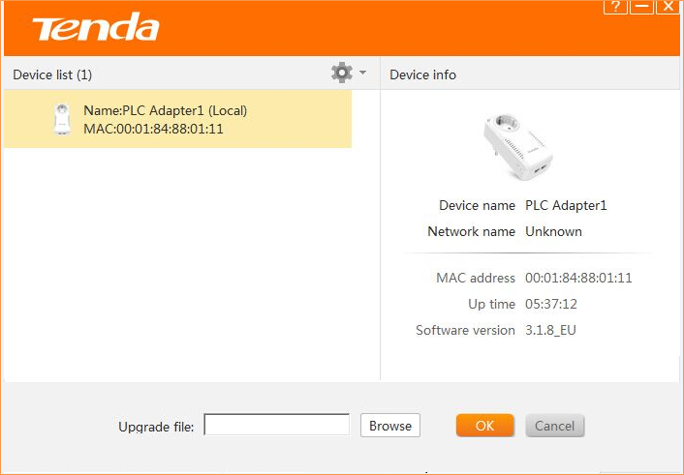

Enter the setting page of the management software, and check all of the powerline adapters that they have established the powerline network automatically in the same electricity meters from the left list. Click the icon of setting , then it enables to modify SSID of device and network, setup QOS and restore to factory default setting so on.

